Newsletter now being printed by Eimear Deehan Phone 087 171 6745 or e-mail: kilglassparishnewsletter@outlook.com
Deadline 9pm latest on Thursdays for inclusion.
ALL ROTAS NOW AVAILABLE ON PARISH WEBSITE (IN NEWSLETTER TAB)
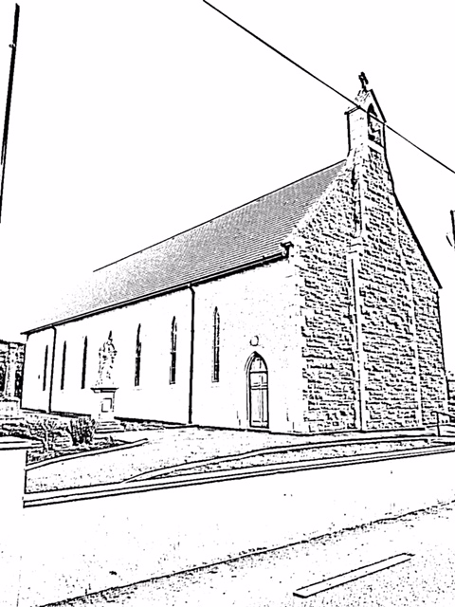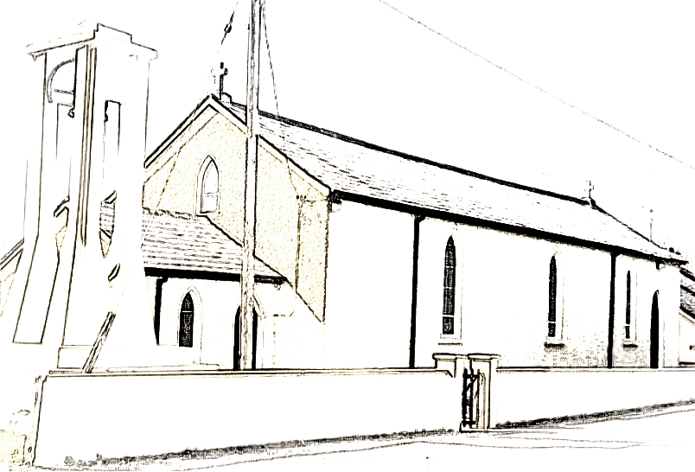
Masses & Intentions this week: (Monday 9th - Sunday 15th March 2020)

Church of Our Lady of Mount Carmel, Rooskey RESPONSIBLE STEWARDSHIP €525
Sunday 8th March: Mass at 11:30am For You
Monday 9th March: Mass at 10am For Protection
Tuesday 10th March: Mass at 10am Private Intention
Wednesday 11th March: Mass at 10am Private Intention
Friday 13th March: Mass at 10am For Young People
Sunday 15th March: Mass at 11:30am Mary Scanlon, Anniversary
EUCHARISTIC ADORATION continues in Rooskey Church each Tuesday from 6 - 7 p.m

Church of the Sacred Heart, Kilglass RESPONSIBLE STEWARDSHIP €355

Sunday 8th March: Mass at 10.30am Joe Regan, 6th Anniversary

Saturday 14th March: Baptism at 12noon

Sunday 15th March: Mass at 10:30am Hubert Geelan, Anniversary

St. Anne’s Church Slatta RESPONSIBLE STEWARDSHIP €165
Saturday 7th March: Mass at 6.00pm Tommy & Alice Deehan, Anniversary
Saturday 14th March: Mass at 6.00pm Jim Feeney, Anniversary
Doctors’ Rota: For weekend and after-hours calls contact MIDOC Tel: 1850 302 702
Dr.Rogers will do early morning bloods at 6.30am each Tuesday and Wednesday at the Rooskey surgery. Nurse Moya will be available from 9.30 am to 10.30 am by appointment also. Please ring Claire for further information and to ensure availability.
COMMUNITY NOTICE
Activities in the Community Centre, (Old School) Rooskey 9th – 15th March 2020
Monday 9th March | Karate 5 – 6pm  Kilglass/Tarmonbarry scouts 6.45 -7.45pm
Tuesday 10th March | Active Retirement Group 11:30am  Tracy O’Neill Dancing Class 6 – 9pm  AA Group 9pm
Wednesday 11th March | Parent & Toddler Group 10:15 – 12:15am  Speech & Drama 5 – 7pm  Tracy O’Neill Dancing Class 6 – 9pm
Thursday 12th March | Tracy O’Neill Dancing Class 5 -9pm
Friday 13th March | Tracy O’ Neill Dancing Class 6 – 9pm
Saturday 14th March | Yoga Class 10 - 11am
PROGESSIVE 25: 1st Pat Mulloolly, 8 games. 2nd John Joe Cox, 7 games. Ticket Winner Peter Joe Fitzmaurice. New players welcome.
KILGLASS GAELS LOTTO: Numbers drawn on 29.2.20: 16,20,21,28. BONUS 23. No Jackpot Winner. 2x3
number winners - €100 each: C. Smith and E&E. Next Week's Jackpot: €10,400- for 4 Correct Numbers, €14,400- for 4 Correct Numbers PLUS Bonus Number. Draw for 7th March in The Weir Lodge. Draw for 14th March in Noel's.
KILGLASS LADIES BONUS BALL: Wed 4th March - No.45 – Francie Conboy & Majella McClean - €50each
KILGLASS GAELS BINGO: Saturday Night in Kilglass Centre @8:30pm - Jackpot €5750 - 46 calls
Yoga Class: Rooskey Centre every Saturday morning 10 – 11am. Contact Denise 086 8846024
Slatta National School: is now enrolling for new entrants for September 2020. Please contact the
School on 071 9638818 for further enquiries. Visit the school website http://slattans.scoilnet.ie/blog/ to learn more about the school
"Win a Home in London worth over €800,000": Roscommon GAA is offering you a chance to win a luxury apartment at 502 Hercules House, 18 Botanic Square, London City Island, in the current Club Rossie competition. Enter online at www.WinAHomeInLondon.com for just €100.00 or contact Nuala Diffley 087 6747177 for details. Your support will support the re-development of Dr. Hyde Park and The Dermot Earley Centre of Excellence
TEXT ALERT: Annual Subscription of €5 is now due for the text Alert. All payments must be in by March 31st. Members who have not paid by this date will be deleted and will receive no further texts. For payments contact Aidan Tully, PJ Corcoran, Thomas Tighe, Joe Rogers. K.S.R. TEXTALERT.
Little Live Wires Parent & Toddler Group: Every Wednesday from 10.15am – 12.15pm at the Rooskey Centre. New parents/guardians/toddlers are always welcome.
BALLYFEENEY N.S: is now accepting applications for enrolment for September 2020. Please contact the school secretary on 071 9633855 for any information.
ROOSKEY N.S: is now accepting applications for enrolment for September 2020. Please contact the school secretary on 071-9638774 for any information
Rooskey Community Afterschool: MONSTER AUCTION in aid of Rooskey Community Afterschool will take place on Sunday 5th April 2020 at 2pm. Venue: Kilglass Gaels GAA centre. All types of items in good condition welcome. Hosted by auctioneer Tom Cox and numerous guest sellers. Small entry fee applies for sellers. For terms of entry and any other queries please contact Barry on 0860771635. Your support is appreciated and donations are very welcome. Proceeds are to help complete new After School building in Rooskey village. An information evening will take place on Wednesday 11th March at 7pm in the Rooskey Centre (old school) regarding the establishment of a Pre School service in Rooskey. All parents interested in this service, your attendance is important.
COYLE BUS HIRE: Transport to and from Scoil Mhuire Strokestown available for the following areas, Rooskey, Kilglass, Tarmonbarry, Slatta and Scramogue for more information contact Michael Coyle on 086 315 3410.
BADMINTON: continues on Wednesday nights @8:30pm everyone is welcome.
HORTICULTURE CLASS: Starting on Thursday 16 April for 4 weeks at the Rooskey Centre from 11am – 1pm. Come and enjoy some summer planting, information, and refreshments. €5 per class. Call Patricia 086 8534100 to book.
NUTRITION AND HEALTHY EATING CLASS: Starting at the Rooskey Centre after Easter. (Date and details later) Contact Patricia 086 8534100 to book
MENS SHED: On Friday 27 March in Reynolds at 9.30pm in aid of the Men's Shed. Table of 4 €40. Please support.

