Newsletter now being printed by Teresa Reynolds Phone 087 6575272 or e-mail: kilglassparishnewsletter@outlook.com - Deadline 9pm latest on Thursdays for inclusion for weekend
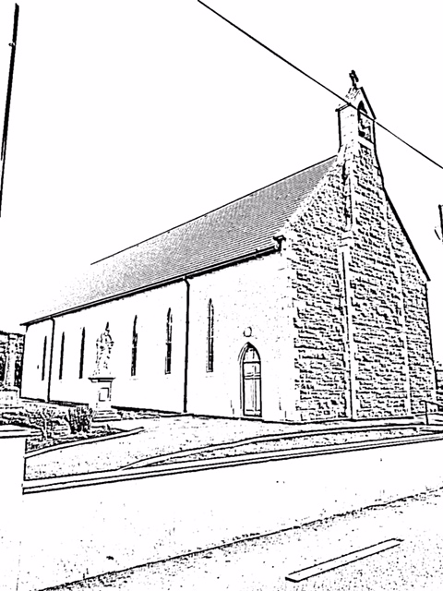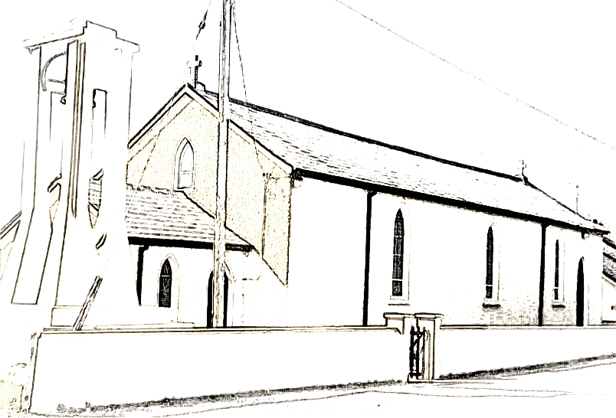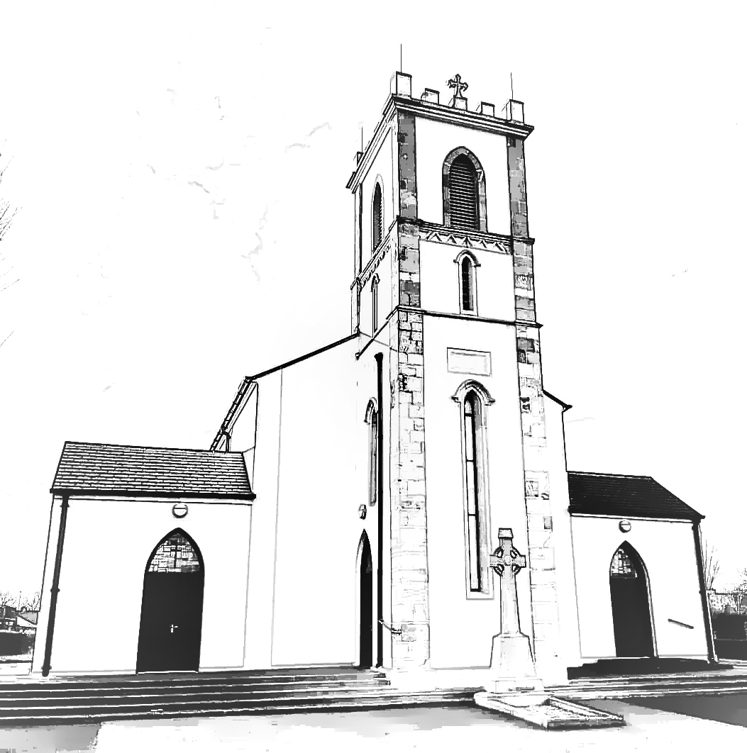

Masses & Intentions this week: (Monday 11th March - Sunday 17th March, 2019

Church of Our Lady of Mount Carmel, Rooskey Responsible Stewardship €480
Sunday 10th March: Mass at 12noon Deceased Members of Kilglass GAA
Monday 11th March: Mass at 10am People who are ill
Tuesday 12th March: Mass at 10am Looking ahead with Courage
Wednesday 13th March: Mass at 10am Young People sitting Exams
Friday 15th March: Mass at 10am Peace in the Home
Sunday 17th March: Mass at 12noon St Patricks Day Mary Scanlon

Church of The Sacred Heart, Kilglass Responsible Stewardship €395

Sunday 10th March: Mass at 10.30am Joe Regan

Sunday 17th March: Mass at 10.30am St Patricks Day Hubert Geelan

St. Anne’s Church Slatta Responsible Stewardship €200
Saturday 9th March: Mass at 7.00pm Jim Feeney
Saturday 16th March: Mass at 7.00pm Bernie Mullaney. Teresa Carlos
EUCHARISTIC ADORATION continues in Rooskey Church each Tuesday from 6 – 7 p.m.
RECENT DEATHS: Please pray for the repose of the Soul of Ashleen Mulligan (nee Hanley) Sandymount and formerly of The Glebe, Rooskey who sadly passed away last week. May She Rest in Peace.
Doctors’ Rota: For weekend and after-hours calls contact MIDOC Tel: 1850 302 702. Dr. Rogers will do early morning bloods at 6.45am Tue, Wed and Thurs every week. Please check with Claire to ensure her availability. Nurse Moya also available for bloods daily in Rooskey Surgery 9.30am
COMMUNITY NOTICES
Activities in the Community Centre, (Old School) Rooskey 11th March - 17th March 2019.
Mon 11th March | Karate Class 5 - 6pm KT Scouts 6.45 – 8pm
Tues 12th March | Tracy O Neill Dancing Class 6 – 9pm AA meeting 9pm
Wed 13th March | Parent & Toddler Group 10.15-12.15pm Speech & Drama Class 5 – 7pm  Tracy O Neill Dancing Class 6 - 9pm
Thurs 14th March | Tracy O Neill Dancing Class 5 – 9pm
Fri 15th March | Tracy O Neill Dancing Class 6 – 9pm
BARGAIN BASKET: The “Bargain Basket” Charity Shop now open. All proceeds to renovation of your Community Centre. Donations welcome. Please support.
Opening Hours - Mon, Tue & Wed 11am – 2pm Thurs & Fri 10am – 4pm Sat 11am – 2pm
SENIOR CITIZENS CHRISTMAS PARTY COLLECTION: will take place at all Churches on the weekend of 9th/10th March. Your generosity would be greatly appreciated.
JOB VACANCIES: Vacancies have occurred in the Rooskey/Tarmonbarry area for General Operatives. Scheme criteria applies to the position. Further information and Expression of interest forms can be obtained by contacting the Rooskey Centre office at 071 96 58631 between 10am & 2pm Mon – Fri
KSR TEXT ALERT: Annual subscription of €5 is now due for the text Alert. All payments must be in by March 31st. Contact Aidan Tully, PJ Corcoran, Thomas Tighe, Joe Rogers. Thank You.
KILGLASS ROOSKEY SLATTA CLYCLING GROUP: Monday mornings from Rooskey Centre at 10.30am. SPRING CLASSES: The following classes will commence shortly depending on numbers, - Grow your own Herbs and Spring Planting, Social Dancing, and Arts and Crafts. If interested in any of the classes leave your name with Patricia at the Rooskey Centre or call 086 8534100 or 071 9658631 between 10am – 2pm.
MULTIPLE SCLEROSIS IRELAND ROSCOMMON BRANCH AGM: The 41 st Annual General Meeting of Multiple Sclerosis Ireland Roscommon Branch will be held on Tues 12th Mar 2019 at 7.30pm in St. Joseph’s Community Resource Centre, Abbeytown, Boyle, County Roscommon. New members and all interested parties are invited and are very welcome to attend.
KILGLASS GAELS BINGO: Every Saturday Night in Kilglass Centre @ 8.30pm - Jackpot €3300 43 calls.
ROOSKEY HERITAGE FESTIVAL: are hosting a St. Patrick's Day Parade in Rooskey on Sunday 17th March, leaving from the church car park at 5pm. All welcome, free to enter, prizes for best display. Please email rooskeyheritagefestival@gmail.com in advance to register your group.
KILGLASS GAELS FUNDRAISING DRAW: Kilglass Gaels are holding a Fundraising Draw on Easter Sunday night with fantastic prizes - 1st - €2000. 2nd €500. 3rd €250. 4th €250. 5th Hamper worth €500. 6th Tablet worth €180. 7th Pass to Tayto Park worth €150. 8th Self Catering Galway. 9th 24" TV. 10th €100 Cash & Dinner Voucher in Leinster House - Tickets priced at just €10 each. Club members will be selling tickets in the coming weeks and we look forward to your continued support.
BADMINTON: will be at the later time of 9.00pm on Wednesdays for the next 3 weeks in the Centre.
HANDBALL: continues on Thursdays at 7.30pm in the Centre. Contact Anthony on 087 7640677.
KILGLASS LADIES BONUS BALL: Wed 6th Mar No.27 - Winners - Patrick McGuire & Ger Donoghue €50ea
KILGLASS GAELS LOTTO: Numbers drawn 2nd March - 42,9,13,19. Bonus No.1. No Jackpot Winner.
3 x 3 Number Winners - €67 each - McHughs Mullagh, Thomas Hanley Kilbarry, Frank McGuire Drumminmore. Next week's Jackpot: €6,200 - for 4 Correct Numbers. €9,200 - for 4 Correct Numbers plus Bonus Number. Draw 9th March in The Weir Lodge. Draw 16th March in Noel's.
PROGRESSIVE 25: continues on Tuesdays at 8.30pm in Kilglass GAA Centre Results for last week - 1st Mickey Tracey - 6 games. 2nd Des Yeoman - 5 games. New players welcome.
SOCIAL DANCING CLASS: Commencing on Monday 25 March at the Community Centre Rooskey at 11am. Everyone welcome. Call Patricia 086 8534100 to book. Everyone welcome.
THE ST. PATRICK'S ST BARRY'S WAY PILGRIMAGE LAUNCH: Sean Browne who was born and reared in Cloonfad and went to school in Cloonfour NS has recently returned to live in the Barntown Cloonfad. Sean is embarking on an interesting project that would be very relevant to the history of the area, both religious and secular. Sean wants to identify and open up a pilgrim tourist trail. The road and route by which the missionary's in the time of St Patrick and our local St Barry travelled to preach to the native tribes of the time to convert them to believe in the Gospel. These native tribes were of course Pagan. In this area the chief of them are the ancestors of the O Hanleys, the Mac Aoghain, the O Farrells, the O Duffys and the O Connors and other well known Gaelic families. Sean is launching this most interesting project on St Patrick's Day next with a pageant to commemorate and honour the conversion of the greatest of our own, Barry who founded he churches in our local Kilbarry, Kilbarrack Dublin, Kilbey in Meath and also Kilberry in Waterford. Sean hopes to speak briefly at the masses this week and explain his project. Provisional Timetable March 17 Morning - Pilgrimage trail with Pageant Launch in Barntown. Lunch Performance Pageant Tarmonbarry. Evening 5pm - Performance Pageant at Rooskey Parade Traditional Musicians, Dancers and Singers Welcome. For more details phone Sean at 087 6788674
MARRIED COUPLE: The married couple were both 70 years old and were celebrating their 50th wedding anniversary. That Night, god appeared to them in prayer to congratulate them for their faithfulness and granted them one wish each. The wife wanted to travel around the world. POOF!!! The wife had two tickets in her hand for a world cruise. Next, God asked the husband what he wanted. He said, I wish i had a wife thirty years younger than me. POOF!! The husband was 100!. 
New Rota for Ministers of the Eucharist in Kilglass Church are available at the back of the Church

